1.Display the details of THOSE WHO are drawing the same SALARY.

QUERY:

SELECT NAME, SALARY FROM PROGRAMMER WHERE SALARY = any(SELECT SALARY FROM PROGRAMMER P GROUP by SALARY HAVING SALARY=P.SALARY AND COUNT(*)>1);

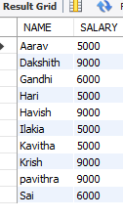

2.Display the details of SOFTWARE developed by male PROGRAMMER earing MORE than 3000?

QUERY:

SELECT SOFTWARE.* FROM PROGRAMMER P,SOFTWARE S WHERE P.NAME=S.NAME AND SALARY>3000 AND SEX='m';

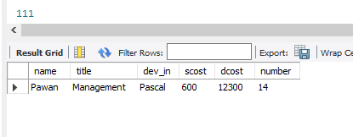

Display details of Packages developed in PASCAL by male PROGRAMMER.

QUERY:

SELECT s.* FROM PROGRAMMER P,SOFTWARE S WHERE P.NAME=S.NAME AND SEX='f' AND DEV_IN='Pascal';

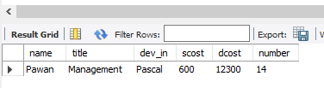

4.Display the details of these PROGRAMMER WHO joined BEFORE 1990.

QUERY:

SELECT * FROM PROGRAMMER WHERE TO_CHAR(DOJ,'YY')<90;

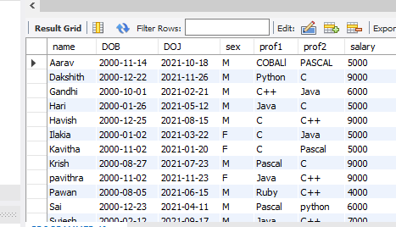

5 Display details of software developed in C by female programmers of PRAGATHI.

SELECT s.* FROM SOFTWARE S,STUDIES ST,PROGRAMMER P

WHERE S.NAME=ST.NAME AND P.NAME=S.NAME AND SEX='f' AND

Splace='Pragathi';

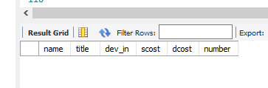

6. Display NUMBER of Packages NUMBER of copies SOLD and sales value of EACH PROGRAMMER Institute-wise.

QUERY:

SELECT STUDIES.Splace, COUNT(SOFTWARE.DEV_IN), COUNT(SOFTWARE.SOLD), SUM(SOFTWARE.SOLD*SOFTWARE.SCOST) FROM SOFTWARE,STUDIES WHERE SOFTWARE.NAME=STUDIES.NAME GROUP BY STUDIES.Splace;

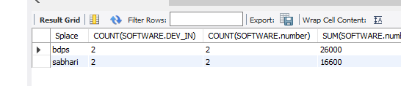

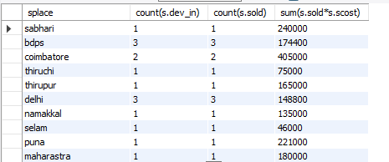

8 Display the details of the software that was developed by male programmers born BEFORE 1965 and female programmers born AFTER 1975.

select s.* from.PROGRAMMER P,.software s

where s.name=p.name and (sex='m' and year(dob)<1964 )and (sex='f' and year(dob)>1975);

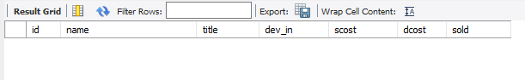

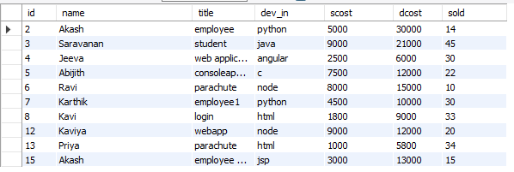

10 Display details of software that was developed in the language which is NEITHER first NOR second proficiency of the programmer.

SELECT S.*

FROM assessmentdatabase.SOFTWARE S, assessmentdatabase.PROGRAMMER P

WHERE S.NAME=P.NAME AND(DEV_IN <> PROF1 AND DEV_IN<>PROF2);

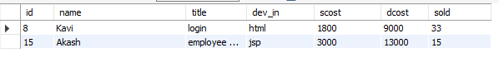

11 Display details of software developed by male students of SABHARI.

SELECT p.*,st.splace,s.dev_in

FROM assessmentdatabase.SOFTWARE S, assessmentdatabase.PROGRAMMER P,assessmentdatabase.STUDIES ST

WHERE S.NAME=P.NAME AND S.NAME=ST.NAME AND ST.NAME=P.NAME AND SEX='M' AND SPLACE='SABHARI';



12 Display the names of programmers WHO HAVE NOT developed any package.

SELECT NAME

FROM assessmentdatabase.PROGRAMMER

WHERE NAME NOT IN (SELECT NAME FROM assessmentdatabase.SOFTWARE);



13 What is the total cost of the software developed by the programmers by APPLE?

SELECT SUM(SCOST)

FROM assessmentdatabase.SOFTWARE S,assessmentdatabase.STUDIES ST

WHERE S.NAME=ST.NAME AND SPLACE='APPLE';

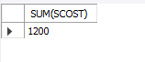

14 Who are the programmers WHO JOINED in the same day?

SELECT NAME,doj

FROM assessmentdatabase.PROGRAMMER

WHERE day(doj)=ANY(SELECT day(doj)

FROM assessmentdatabase.PROGRAMMER

GROUP BY day(doj) HAVING COUNT(*)>1);

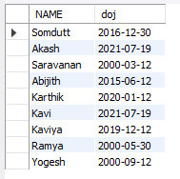

15 Who are the programmers WHO HAVE THE SAME PROF2?

SELECT NAME,prof2

FROM assessmentdatabase.PROGRAMMER

WHERE PROF2=ANY(SELECT PROF2

FROM assessmentdatabase.PROGRAMMER

GROUP BY PROF2 HAVING COUNT(*)>1);

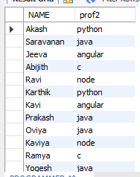

16. Display the total sales values of SOFTWARE, institutes-wise.

SELECT STUDIES.splace,SUM(SOFTWARE.SOLD*SOFTWARE.SCOST) FROM SOFTWARE,STUDIES WHERE STUDIES.NAME=SOFTWARE.NAME GROUP by STUDIES.splace;

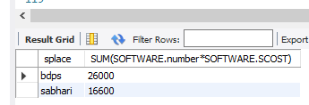

17.In which institutes did the Person who developed the COSTLIEST Package study?

SELECT splace FROM SOFTWARE st,STUDIES s WHERE s.NAME=st.NAME GROUP by splace,DCOST HAVING max(DCOST)=(SELECT max(DCOST) FROM SOFTWARE);

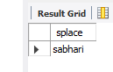

Which language listed in Prof1 AND Prof2 HAS NOT BEEN used to develope any Package?

SELECT Prof1 FROM PROGRAMMER WHERE Prof1 not in(SELECT DEV_IN FROM SOFTWARE) union SELECT Prof2 FROM PROGRAMMER WHERE Prof2 not in(SELECT DEV_IN FROM SOFTWARE);

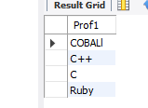

How much does the Person WHO Developed the HIGHEST selling Package earn AND WHAT course did he/she undergo?

SELECT P1.SALARY,s2.course FROM PROGRAMMER P1,SOFTWARE s1,STUDIES s2 WHERE P1.NAME=s1.NAME AND s1.NAME=s2.NAME AND SCOST=(SELECT max(SCOST) FROM SOFTWARE);

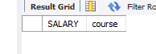

How many months will it take for each PROGRAMMER to recover the cost of the course underwent? SELECT P.NAME,ceil(ccost/SALARY) FROM PROGRAMMER P,STUDIES s WHERE s.NAME=P.NAME;



Which is the COSTLIEST Package Developed by a Person with under 3 years exPenence? SELECT x.title FROM SOFTWARE x, PROGRAMMER y WHERE (months_between(SYSDATE, y.DOJ)/12) > 3 AND x.NAME=y.NAME;